Pokhara University

Level: Bachelor | Semester – Fall | Year : 2010
Programme: BE |  | Full Marks : 100
 |  | Pass Mark : 45
Course: Engineering Mathematics II |  | Time : 3 hrs

Candidates are required to give their answers in their own words as far as practicable.
The figures in the margin indicate full marks.

Attempt all the questions.

1. | - Find the equation of the plane through 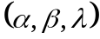and the line x = py+q = rz+s.  - Find the equation of sphere through the circle x²+y² = 4, z = 0 and is cut by the plane x+2y+2z = 0 in a circle of radius 3. | 7  8
2. | - If 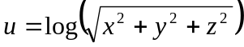, evaluate 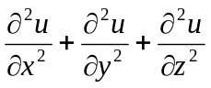.  OR  State Eulers theorem for homogeneous function of x, y and z with degree n. If 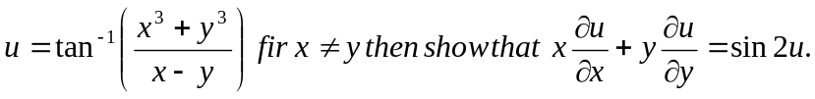  - If the sum of the dimension of a rectangular swimming pool is given, show that the amount of water in the pool is maximum when it is a cube. | 7  8
3. | - Evaluate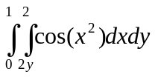, by reversing the order of integration.  - The base of a solid is the region in xy plane that is bounded by the circle x²+y² = a², while the top of the solid is bounded below by the parabola of az = x²+y². Find the volume of solid. | 7  8
4. | - Define order and degree of the differential equation. Find the particular solution of the differential equation 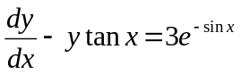where y(0)=4.  - Find the general solution of the differential equation 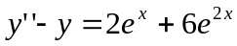. | 7  8
5. | - Find the power series solution of he differential equation y’’ = 4y.  OR  Define Legendre’s equation and find its solution.  - Solve the initial value problem (by usine Laplace Transform)y’’+2y’+y=e^{-x} where y(0) = -1, y’(0) = 1. | 7  8
6. | - State and Prove first shifting theorem on Laplace transform and evaluate 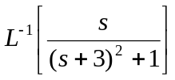.  - Evaluate the Laplace transform of following:  - t² cos3t  - 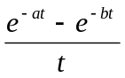. | 7  8
7. | Short questions:  - find the equation of tangent plane on the sphere x²+y²+z²+2x-6y = 1 at (1, 2, -2)  - find I. F of the linear differential equation, 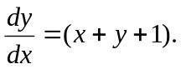  - inf 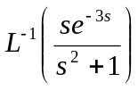.  - Evaluate 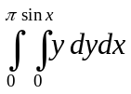  - Verify Eulers theorem for u = x²+y² | 2x5

